Lab 4 Report: Informed Search: Heuristics & A*
Course: Artificial Intelligence Lab
Topic: Heuristic Evaluation, A* Algorithm & UCS Comparison
1. Trigger Questions (Courage - Thinking)
Q1: What makes a heuristic useful?
Answer:
A heuristic is useful if it provides an accurate estimate of the remaining path cost to the goal (h(n)) while being computationally inexpensive to compute. It directs search towards the goal, significantly reducing expanded nodes compared to uninformed algorithms.
Q2: What happens when h(n) = 0 for every node?
Answer:
When h(n) = 0 everywhere, f(n) = g(n) + 0 = g(n). The evaluation function reduces strictly to path cost, causing A* search to degenerate into Uniform Cost Search (UCS).
Q3: Why can an overestimating heuristic threaten optimality?
Answer:
An overestimating heuristic (h(n) > h^*(n)) violates admissibility. It makes a node on the true optimal path look artificially expensive, causing A* to discard or delay expanding the optimal route and return a suboptimal path instead.
Q4: How should A* break ties and update better paths?
Answer:
Ties in f(n) values are broken using a fixed convention (such as lower h(n) or alphabetical order). When a cheaper route g(n) to an already discovered node is found, A* updates its best recorded distance (g) and re-enqueues or reprioritizes the node in the priority queue.
2. Task 1: First Three Expansions by Hand
Starting node S, Goal G. f(n) = g(n) + h(n).
Step 1 (Start Node S):
Selected Node: S (g=0, h=5, f=5)
Successors Generated:
A: g = 0+1 = 1, h=4 \implies f = 1+4 = 5
B: g = 0+4 = 4, h=4 \implies f = 4+4 = 8
Frontier State: [(A, f=5), (B, f=8)]
Step 2:
Selected Node: A (g=1, h=4, f=5) [Chosen over B due to lower f value]
Successors Generated:
C: g = 1+2 = 3, h=2 \implies f = 3+2 = 5
Frontier State: [(C, f=5), (B, f=8)]
Step 3:
Selected Node: C (g=3, h=2, f=5) [Chosen over B due to lower f value]
Successors Generated:
G: g = 3+3 = 6, h=0 \implies f = 6+0 = 6
Frontier State: [(G, f=6), (B, f=8)]
Next Selected Node: G (f=6), which satisfies the Goal Test.
- Task 2: Controlled A* vs UCS Comparison
Search Algorithm: Standard A*
Returned Path: S -> A -> C -> G
Total Path Cost: 6
Expanded Node Count: 4
Node Expansion Trace: S(f=5) -> A(f=5) -> C(f=5) -> G(f=6)
Search Algorithm: UCS Control (h=0)
Returned Path: S -> A -> C -> G
Total Path Cost: 6
Expanded Node Count: 5
Node Expansion Trace: S(f=0) -> A(f=1) -> C(f=3) -> B(f=4) -> G(f=6)
Analysis: Standard A* uses heuristic estimates to eliminate the expansion of irrelevant node B, reaching the optimal goal with fewer node expansions compared to UCS.
4. Task 3: Overestimate Heuristic Investigation (h(C) = 10)
Original vs Modified Value:
Original h(C): 2 (True remaining cost h^*(C) = 3; Admissible)
Modified h(C): 10 (Inadmissible, overestimates true cost 3 by 7)
Experimental Result:
Returned Path: S -> B -> G
Total Path Cost: 9 (Suboptimal)
Expanded Node Trace: S(f=5) -> B(f=8) -> G(f=9)
Discussion:
When h(C) was raised to 10, f(C) became 3 + 10 = 13. Because f(C) = 13 > f(B) = 8, A* incorrectly assumed node C belonged to an expensive path and selected node B instead. This demonstrates how violating admissibility breaks path optimality, leading the agent to select a suboptimal cost-9 path over the true cost-6 path.
- Execution Output & Screenshot Placeholder

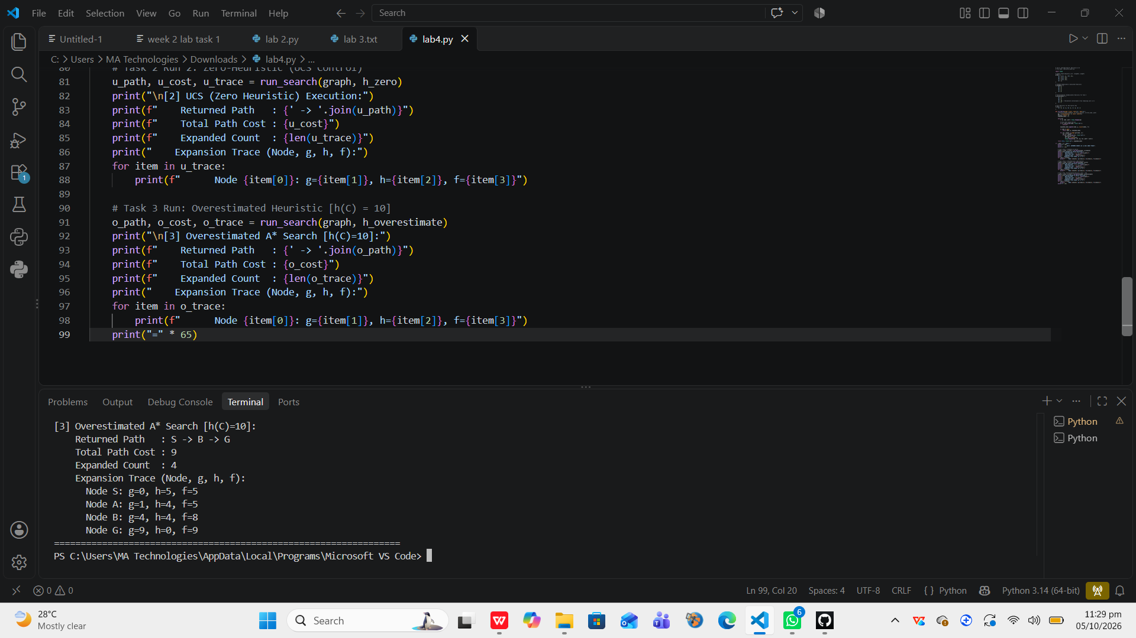
6. Reflection Questions
Q1: What did you learn today?
Answer:
I learned how A* combines path cost g(n) and heuristic estimate h(n) into f(n), and verified how admissible heuristics maintain optimality while saving expansions compared to UCS.
Q2: How will you apply this in a real AI system?
Answer:
I will implement A* with straight-line or Manhattan distance heuristics in robotics and map navigation apps to ensure fast, optimal path planning.
Q3: What failed or surprised you?
Answer:
It was eye-opening to see that overestimating just one node's heuristic value (h(C)=10) caused A* to completely miss the optimal cost-6 path and return a suboptimal cost-9 path.
Q4: What would you do differently next time?
Answer:
Next time, I will design and verify heuristic consistency (h(u) \le c(u,v) + h(v)) across all graph edges to guarantee optimal performance in graph search without reopening nodes.

